Country Project using PIG

Problem Statement

**A.Count number of countries based on landmass.**

* country_data = LOAD 'countrydata.txt' USING PigStorage(',') as (name:chararray, landmass:int, zone:int, area:chararray, population:chararray, lang:int, rel:int, bar:int, stripes:int, col:int, red:int, green:int, blue:int, gold:int, white:int, black:int, orange:int, hue:chararray, circle:int, cross:int, saltire:int, quars:int, suns:int, cres:int, triangle:int, icon:int, animate:int, text:int, left:chararray, right:chararray);
* grouped_data = GROUP country_data by landmass;
* count_data = FOREACH grouped_data GENERATE group,COUNT(country_data);
* DUMP count_data;

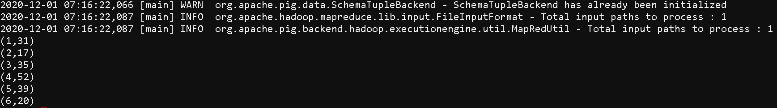

**B.Find out top 5 country with Sum of bars and strips in a flag.**

* country_data = LOAD 'countrydata.txt' USING PigStorage(',') as (name:chararray, landmass:int, zone:int, area:chararray, population:chararray, lang:int, rel:int, bar:int, stripes:int, col:int, red:int, green:int, blue:int, gold:int, white:int, black:int, orange:int, hue:chararray, circle:int, cross:int, saltire:int, quars:int, suns:int, cres:int, triangle:int, icon:int, animate:int, text:int, left:chararray, right:chararray);
* foreach_data = FOREACH country_data GENERATE name,$7+$8;
* grouped_data = GROUP foreach_data All;
* bar_data = FOREACH grouped_data {

ord = ORDER foreach_data BY $1 DESC;

top = LIMIT ord 5;

GENERATE FLATTEN(top);

};

* DUMP bar_data;

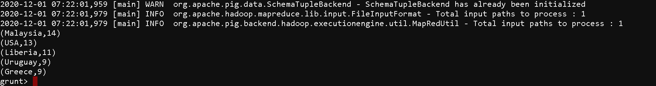

**C.Count of countries with icon**.

* filtered_icon_data = FILTER country_data BY icon == 1;
* grouped_icon_data = GROUP filtered_icon_data BY icon;
* count_icon_data = FOREACH grouped_icon_data GENERATE group, COUNT(filtered_icon_data);
* DUMP count_icon_data;



**D.Count of countries which have same top left and top right color in flag.**

* filtered_flag_data = FILTER country_data BY $28 == $29;
* grouped_flag_data = GROUP filtered_flag_data All;
* count_flag_data = FOREACH grouped_flag_data GENERATE group, COUNT(filtered_flag_data);
* DUMP count_flag_data;



**E.Count number of countries based on zone.**

* grouped_zone_data = GROUP country_data by landmass;
* count_zone_data = FOREACH grouped_zone_data GENERATE group,COUNT(country_data);
* DUMP count_zone_data;

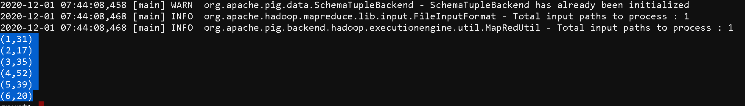

**F.Find out largest county in terms of area in NE zone**.

* filtered_NE_data = FILTER country_data BY zone == 1;
* grouped_NE_data = GROUP filtered_NE_data All;
* max_area_data = FOREACH grouped_NE_data {

ord = ORDER filtered_NE_data BY $3 DESC;

top = LIMIT ord 1;

GENERATE FLATTEN(top);

};

* max_area_country = FOREACH max_area_data GENERATE name,area;
* DUMP max_area_country;



**G.Find out least populated country in S.America Landmass**

* filtered_SA_data = FILTER country_data BY landmass == 2;
* grouped_SA_data = GROUP filtered_SA_data All;
* min_population_data = FOREACH grouped_SA_data {

ord = ORDER filtered_SA_data BY $4 ASC;

top = LIMIT ord 1;

GENERATE FLATTEN(top);

* };
* min_population_country = FOREACH min_population_data GENERATE name,population;
* DUMP min_population_country



**H.Find out largest speaking language among all countries.**

* foreach_data = FOREACH country_data GENERATE name,lang;
* grouped_data = GROUP foreach_data BY lang;
* count_data = FOREACH grouped_data GENERATE group,(int)COUNT(foreach_data);
* grouped_count_data = GROUP count_data All;
* max_lang_data = FOREACH grouped_count_data {

ord = ORDER count_data BY $1 DESC;

top = LIMIT ord 1;

GENERATE FLATTEN(top);

};

* DUMP max_lang_data;



**I.Find most common colour among flags from all countries.**

* grouped_data = GROUP country_data All;
* final_color_data = FOREACH grouped_data GENERATE group,SUM(country_data.$10),SUM(country_data.$11),SUM(country_data.$12),SUM(country_data.$13),SUM(country_data.$14),SUM(country_data.$15),SUM(country_data.$16);
* dump final_color_data;



**J.Sum of all circles present in all country flags.**

* grouped_circle_data = GROUP country_data All;
* sum_circle = FOREACH grouped_circle_data GENERATE group,SUM(country_data.circle);
* dump sum_circle;



**K.Count of countries which have both icon and text in flag.**

* filtered_country_data= FILTER country_data BY ($25 == 1) | ($29!=0);
* coun = FOREACH country_data GENERATE (country_data.text is NULL ? 0 : 1);
* filtered_country_data2= FILTER filtered_country_data1 BY ($29 == 1);
* grouped_text_data = GROUP filtered_country_data All;
* count_text_data = FOREACH grouped_text_data GENERATE group, COUNT(filtered_country_data);
* DUMP count_text_data;

